Nithin S
221IT085

IT253 Lab Assignment 4

1. Write Programs using the following system calls of the LINUX operating system: a. fork, exec, getpid, exit, wait, close, opendir, readdir, stat.

Fork()

Code
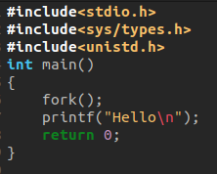

Output

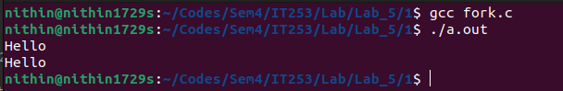

Exec()
Code

prog1

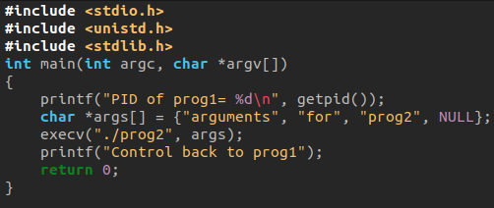

prog2

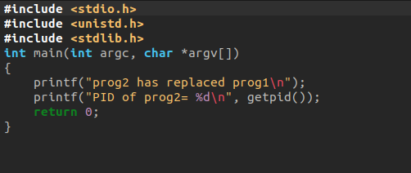

Output

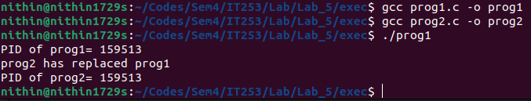

getpid()

Code

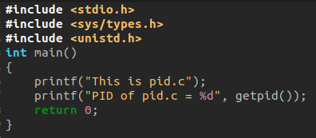

Output

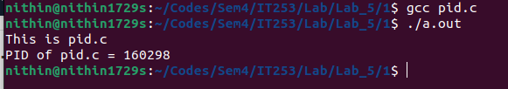

exit()

Code

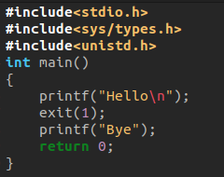

Output
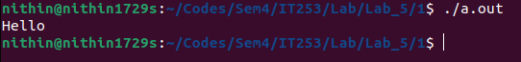

Note: Bye was not printed in the output as the proccess terminated before that.

Wait()

Code

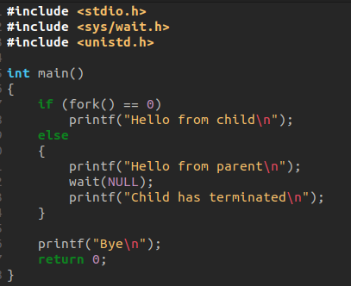

OUTPUT
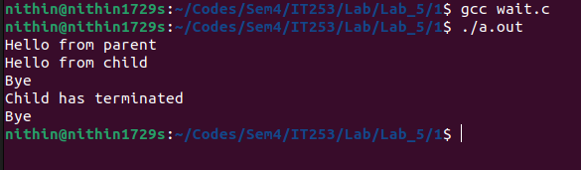

Note: In the parent process, wait(NULL) is called, which makes the parent process wait for the child process to terminate. The wait() function suspends the execution of the parent process until the child process terminates.

Close()

Code

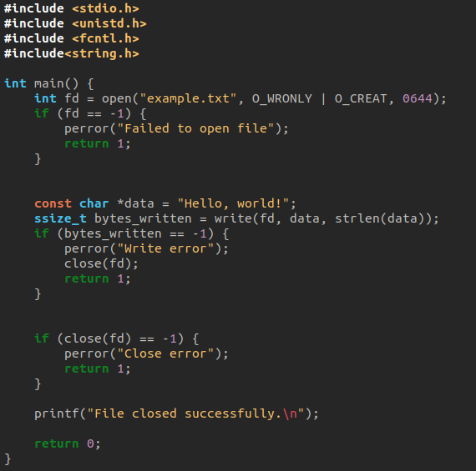

Output

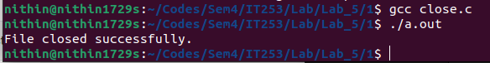

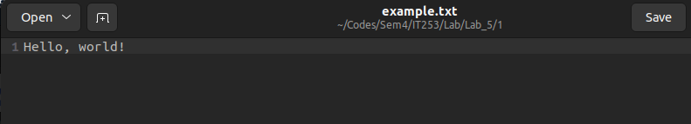

opendir() and readdir()

Code

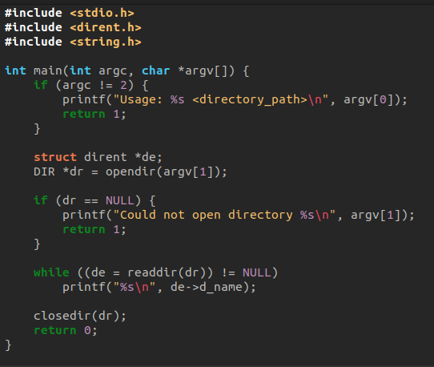

Output

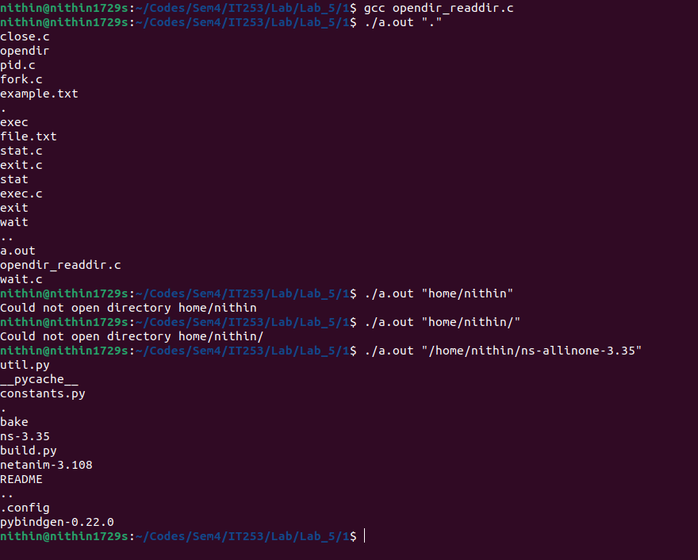

stat

Code

Note: The code is printing the properties of a file named “file.txt”

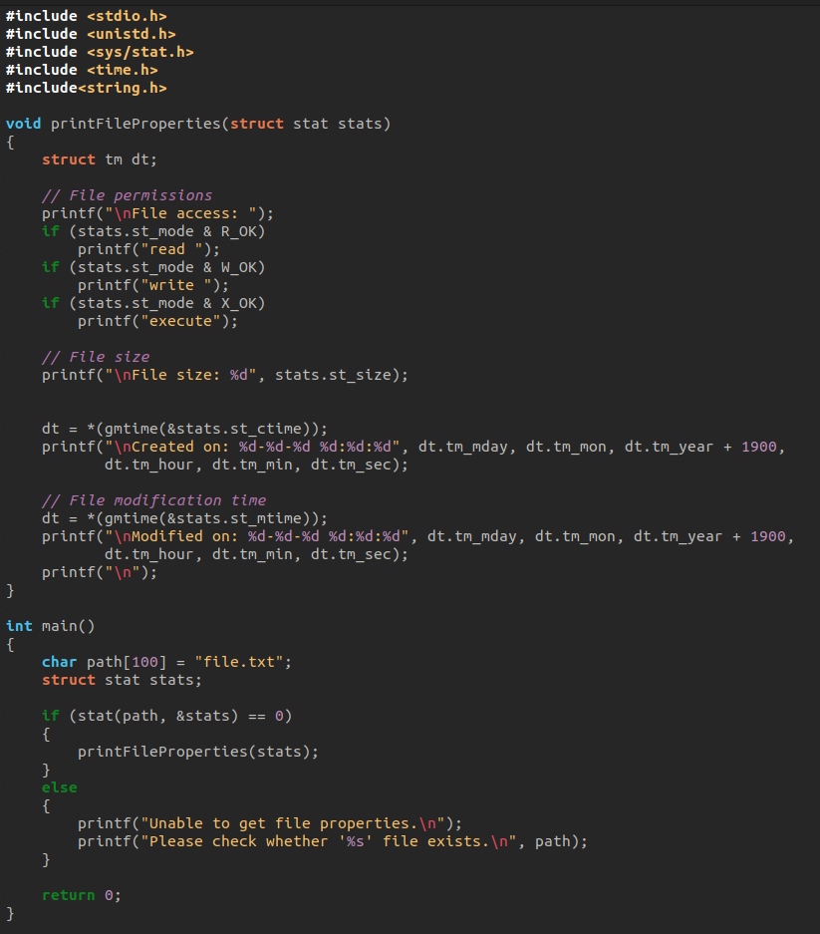

Output

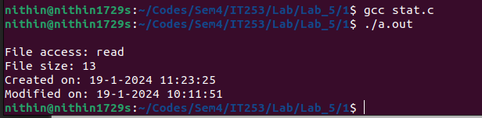

Q2. Write Programs using I/O system calls of LINUX operating system: open, read, write etc.

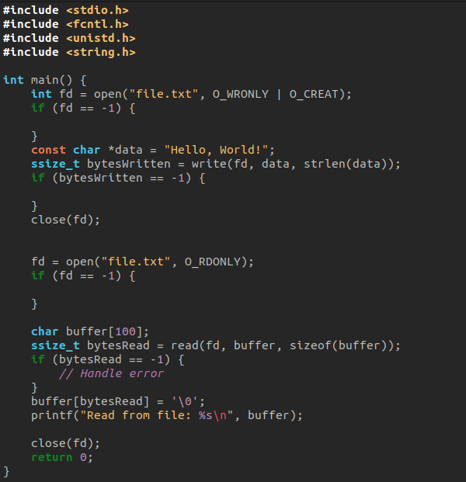

Output

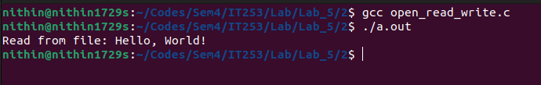

Before:

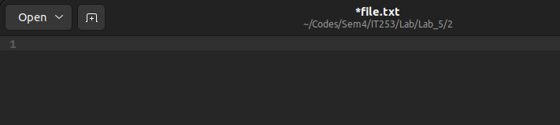

after:

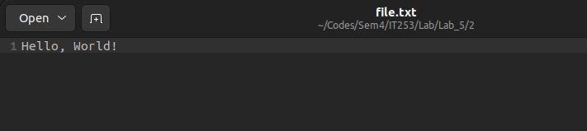

Q3.Write Programs using C to simulate LINUX commands a. ls command, b. grep command

ls

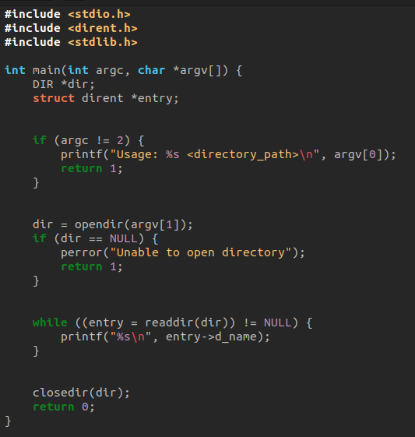

Output

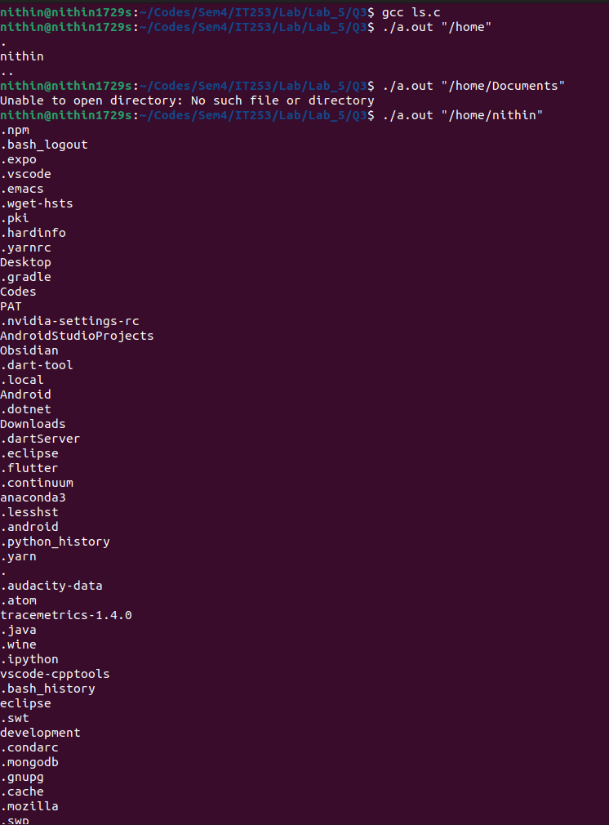

grep

Code

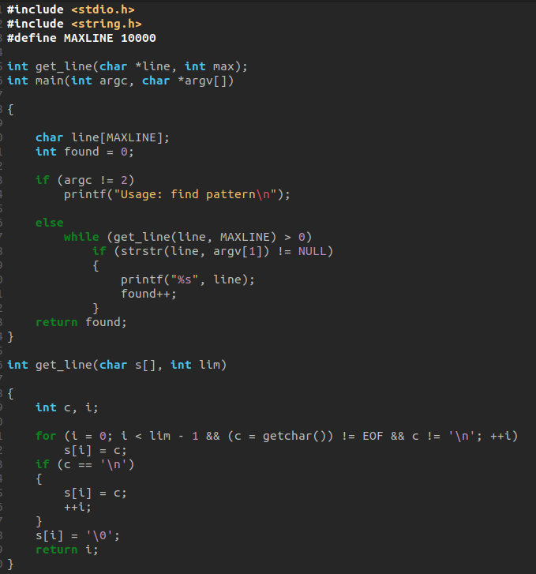

Output



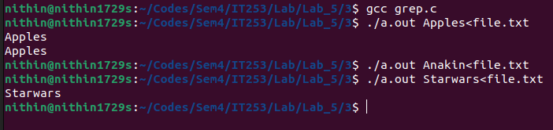

Note: ‘<’ means take the file to the right and make it the stdin for the program to the left.

Q4. Write a program: a) To create parent & child process and print their id.

Code

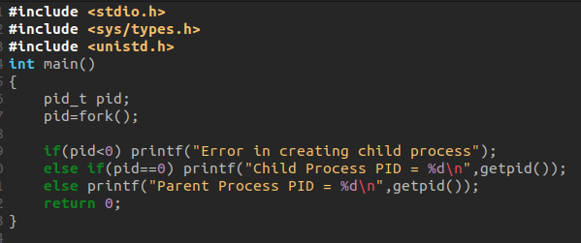

Output

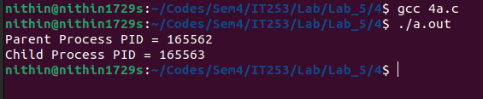

Q4. Write a program: b) To create a zombie process.

Code

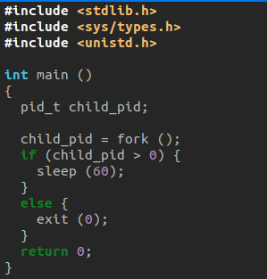

Note: A zombie or a "defunct process" in Linux is a process that has been completed, but its entry still remains in the process table due to lack of correspondence between the parent and child processes.
Usually, a parent process keeps a check on the status of its child processes through the wait() function. When the child process has finished, the wait function signals the parent to completely exit the process from the memory.
However, if the parent fails to call the wait function for any of its children, the child process remains alive in the system as a dead or zombie process.
These zombie processes might accumulate, in large numbers, on your system and affect its performance.
The zombie process created through this code will run for 60 seconds. You can increase the time duration by specifying a time(in seconds) in the sleep() function.

Output

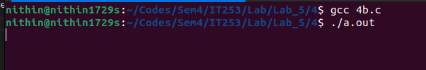

The ps command will now also show this defunct process, open a new terminal and use the below command to check the defunct process

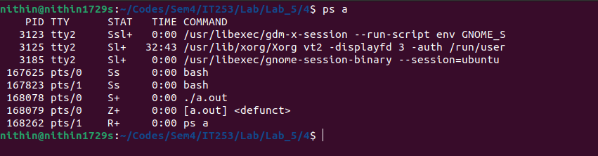

Q4. Write a program: c) To create an orphan process.

Code

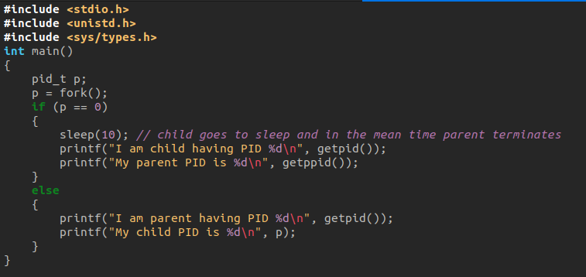

Note:

In this code, we add sleep(10) in the child section. This line of code makes the child process go to sleep for 10 seconds and the parent starts executing. Since, parent process has just two lines to print, which it does well within 10 seconds and it terminates. After 10 seconds when the child process wakes up, its parent has already terminated and hence the child becomes an orphan process. The child process will be made the child of another process so we can see in the ouput screenshots that the parent id of child changes.

Output

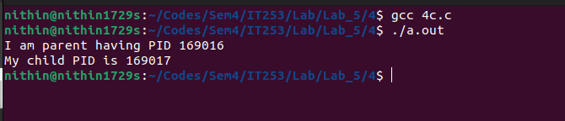

After 10 seconds,

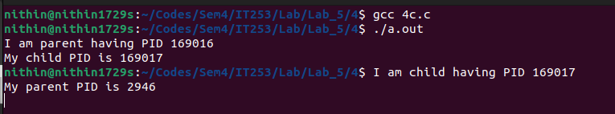

Q4. Write a program: d) To make the process to sleep for a few seconds.

Code

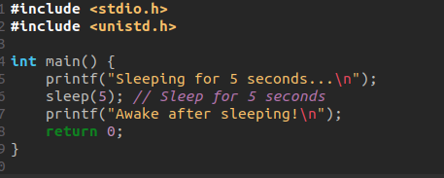

Output

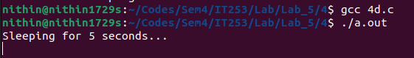

After 5 seconds,

